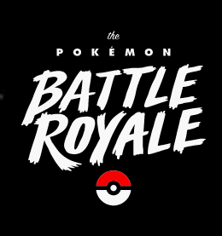

**CS 371 – Final Project Report**

**Members:**

Daniel Burris

Zachary Johnson

Jairo Arreola

John Mullen

Concept

* What is this game about?
  + This game is a Pokémon Arena. The main menu has two buttons, a start button and a help button. When a new game is initiated from the start button, the player will be able to select 1 of 3 random Pokémon, once he selects his Pokémon, he will be able to select another Pokémon from another set of 3 random Pokémon. This continues until the user has six Pokémon. Once he has his deck of Pokémon, he will battle against enemy trainers and see if we can beat all 3.
* Genre
  + Pokémon is generally an instance-based RPG, in this case it’s going to have an RPG style combat, but arena (royal rumble) based gameplay.
* Character Design and Sketch



Main Character & Enemy Trainers

* Target audience
  + Pokémon players; which is anyone aged 3-99.
* Key Features
  + RPG-Style combat.
  + Sudo-random Pokémon matchups / Arena style Pokémon selection.
  + Potions commonly found in Pokémon games.
  + Start menu, Help menu
* References
  + Hearthstone
  + Pokémon Stadium
  + Pokémon Gameboy games

Game Mechanics

* This game is played using a Pokémon style menu loaded with tap events to navigate options such as fight, Pokémon switch, and item use. You can see a basic idea of what the menu looks like in Figure 1. The battle scenes look like Figure 2. The Pokémon select screen looks like Figure 3. You can see our game flow in Figure 5.
* Screenshot and artwork

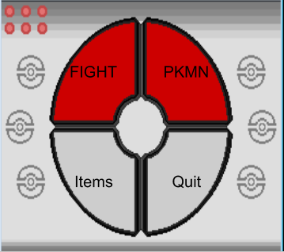

**Figure 1 – Menu during Battle Scene**

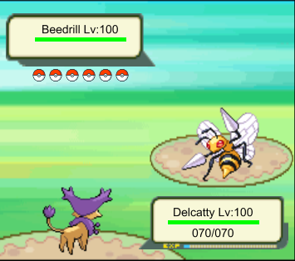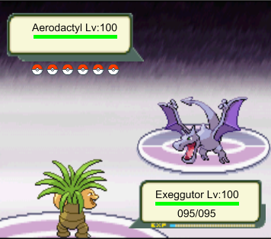

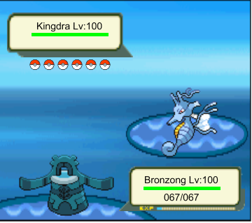

**Figure 2 – Battle Scene**

Quit

Winner / Loser Screen

If player loses

If player wins

Trainer Battle

If (Pokemon == 6)

Pokemon++

Pick Pokemon

Menu

Help

Start

**Figure 4 – Game Flow Diagram**

|  |  |  |
| --- | --- | --- |
| Menu |  | Play button  Help button  Quit button |
| Play button |  | Takes us to the Pokémon select scene |
| Help button |  | Shows new scene that explains game mechanics / how to play. |
| Quit button |  | Closes Application |

**Figure 5 – Game Flow Table**

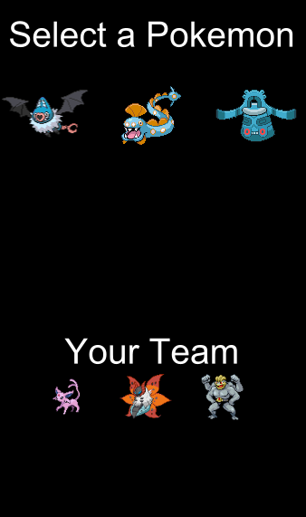

**Figure 3 – Pokémon** **Select Scene**

* Gameplay example
  + You can see our gameplay in the following video we made.
* Control Scheme and Interface
  + You can see our control scheme and interface in the following video we made.
* Scoring System and Achievements
  + There is no scoring system per say. The point of the game is to beat all three trainers. If you lose to any trainer along the way you lose the game.
* Screen Flow

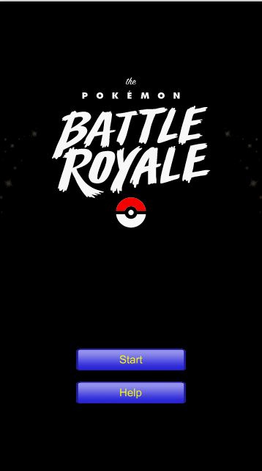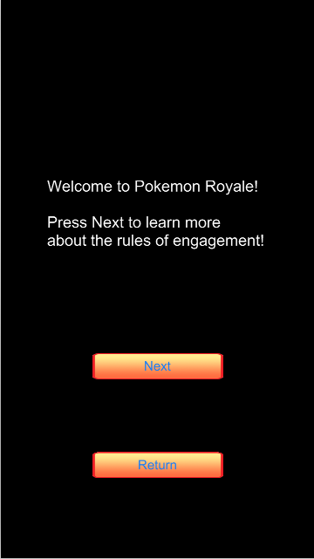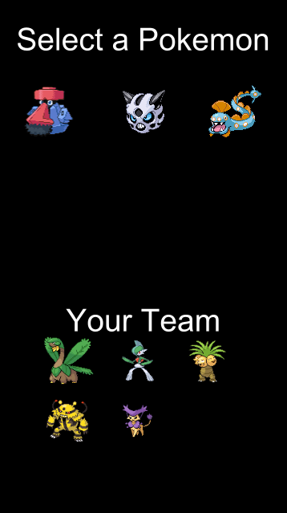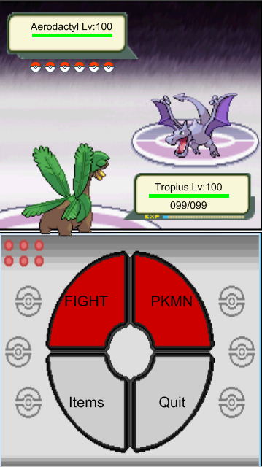

* How your original design has been changed and why?
  + The core game of our final product has not changed much from what we originally intended it to be. The graphics, however, changed a lot. The reason why the graphics changed so much is because we found so many cool sprite sheets and images online that we wanted to upgrade our simple graphics to these more professional looking ones.

Tech

* Issues
  + **Graphics** was not an issue. We found a lot of sprites online, took them into Photoshop and changed them or sliced them. Used parts of them for buttons and overlaid the buttons on top of the background until it looks flesh.
  + **Camera** wasn’t an issue, we have no camera.
  + **Control** **Interface** was a little tricky to figure out, but in the end it worked out well. We think the game looks good visually and controls well.
* Target Platform
  + Android platform, native resolution, portrait only, no landscape because of design space issues. This stayed the same.
* Graphics Assets

|  |  |  |  |  |
| --- | --- | --- | --- | --- |
| 2D |  |  |  |  |
|  | E_trainers |  |  |  |
|  |  | Blue |  |  |
|  |  | Bugsy |  |  |
|  |  | Clair |  |  |
|  | fightScene |  |  |  |
|  |  | animations |  |  |
|  |  |  | battleIntro |  |
|  |  |  | battleIntro2 |  |
|  |  |  | pkmnSummon |  |
|  |  |  | lucasThrow |  |
|  |  | Menu |  |  |
|  |  |  | fight |  |
|  |  |  |  | fightMenuBG |
|  |  |  |  | fightMenuBtn |
|  |  |  |  | fightMenuBtnOnClick |
|  |  |  | Item |  |
|  |  |  |  | itemMenuBG |
|  |  |  | Main |  |
|  |  |  |  | BagButton |
|  |  |  |  | BagButtonOnClick |
|  |  |  |  | enemyPokeball |
|  |  |  |  | FightButton |
|  |  |  |  | FightButtonOnClick |
|  |  |  |  | mainMenuBG |
|  |  |  |  | PokemonButton |
|  |  |  |  | PokemonButtonOnClick |
|  |  |  |  | RunButton |
|  |  |  |  | RunButtonOnClick |
|  |  |  | Pkmn |  |
|  |  |  |  | pkmnMenuBG |
|  |  |  |  | pkmnMenuBtn |
|  |  |  |  | pkmnMenuBtnOnClick |
|  |  |  | Quit |  |
|  |  |  | cancelBtn |  |
|  |  |  | cancelBtnOnClick |  |
|  |  | Stages |  |  |
|  |  |  | GrassBG |  |
|  |  |  | PsychcBG |  |
|  |  |  | WaterBG |  |
|  |  | enemyInfoBox |  |  |
|  |  | playerInfoBox |  |  |
|  |  | Trainer1 |  |  |
|  | gameScene |  |  |  |
|  |  | p1-p9 |  |  |
|  |  | t1-t9 |  |  |
|  | menuScene |  |  |  |
|  |  | animations |  |  |
|  |  |  | slash |  |
|  |  | menuBtn |  |  |
|  |  | menuBtnOnClick |  |  |
|  |  | menuTitle |  |  |
|  | Pokemons |  |  |  |
|  |  | All pokemon… |  |  |
|  |  |  | Battle |  |
|  |  |  | select |  |
|  | b10 |  |  |  |
|  | Button |  |  |  |
|  | p10 |  |  |  |
|  | Pokeball |  |  |  |
|  | pokeballFainted |  |  |  |

* Audio Assets

|  |  |  |
| --- | --- | --- |
| Music |  |  |
|  | Music |  |
|  |  | BlueBattle |
|  |  | BugsyBattle |
|  |  | ClairBattle |
|  |  | Trainer Battle (STEREO) - Pokémon RedGreenBlueYellow |
|  | Sound |  |
|  |  | maxPotion |
|  |  | menuButtonClick |
|  |  | menuButtponClick |
|  |  | normalEffective |
|  |  | NotVeryEffective |
|  |  | onPotionUse |
|  |  | pokeballEffect |
|  |  | pokeballEffect2 |
|  |  | pokemonSelectSound |
|  |  | summon |
|  |  | superEffective |
|  |  | superPotion |

* Required Resources
  + Software
    - Corona SDK
    - GIMP
    - Texture Packer
    - GitHub Repository
    - Advance Map (<http://www.pokecommunity.com/showthread.php?t=127348>)
  + Sprite resources
    - Poke Stadium (<http://www.pokestadium.com/tools/sprites>)
    - Pokémon Trainers Sprite Sheet (<http://kyogremaster.deviantart.com/art/All-Pokemon-Trainer-Sprites-137787432>)
* Work Division and Schedule.

|  |  |  |  |
| --- | --- | --- | --- |
| Members |  |  |  |
| Daniel | Fight Scene | Menu Scene + Defined pokemon | Game Mechanics + Items |
| Jairo | Pokemon Class + sqlController | Trainer Class, Fight scene | Win/Lose/nextEnemy scene |
| Jonathan | Help | Help2 | Help3 |
| Zach | Enemy_Trainer | Defining Pokémon | Game mechanics |

Implementation

* Corona Libraries
  + Sqlite3
  + composer
  + widget
  + scene
* Flowchart

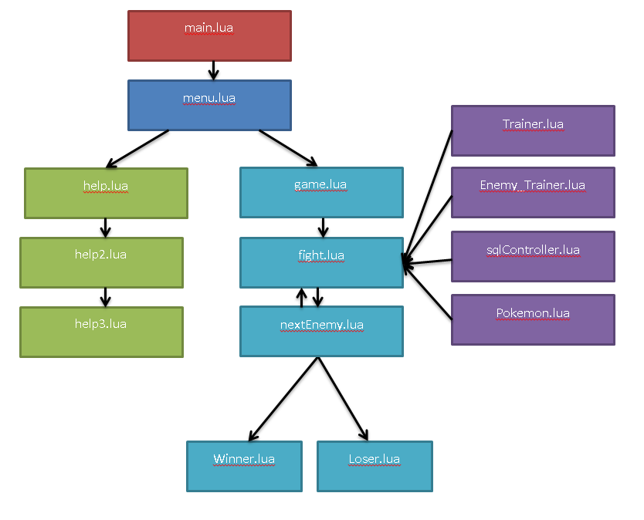

* Explain Data Structure and main functions
  + All of our Pokemon and Trainers are kept in a SQL-lite3 database. We have a sqlController.lua that gives us methods that can pull from the database based on ID’s of pokemon and trainers. Our game is setup using scenes. Our main fight is controller by a series of buttons and action listeners, with our main function being moveMade(). This function is called after any attack and looks at both the player’s pokemon and the enemy’s pokemon, calculates the damage done to each using the Pokemon class, then display a series of text that illustrate what happened in the fight that turn.